UNICEF Toolkit on Diversion and Alternatives to Detention 2009

‘Data collection & record keeping: Sample individual case files’

A. Suggested content of case files:

- Basic information sheet (including e.g.: name, age, sex, address, contact information for legal guardians; date of admission to programme; referral body and contact name; type of offence; conditions of the disposition order – e.g. duration and frequency of attendance in the programme; relevant medical information (may include allergies, or conditions requiring special care); other circumstances relevant to the programme).

- Assessment forms

- Contracts (e.g. between the child and his/her guardians; between the child (and his/her guardians) and the implementing project organisation – e.g. NGO, job placement)

- References and request letters for diversion / alternatives to detention

- Copies of legal documents

- Victim/survivor - offender reconciliation meeting notes

- Progress notes

- Activity plan with deadlines

- Documentation on group interventions

- Photos of children

B. Case Information Form (South Africa: NICRO ‘Youth Empowerment Scheme’)
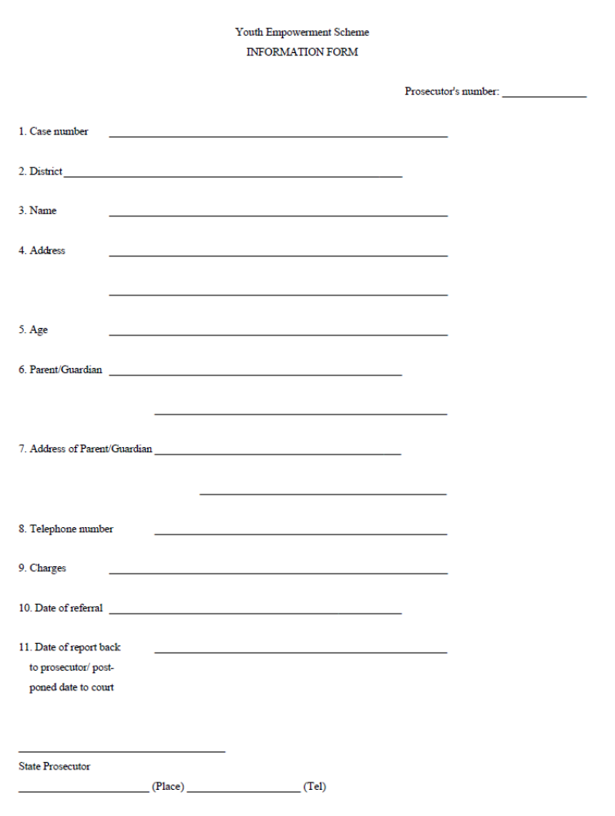
C. Individual case file (Kyrgyzstan)
[This must be kept confidential with access restricted only to those who need to know.]

Name of social worker completing the form:_____________________________
Date: ___________________________________________________________

Basic information about the child
Name
Gender
Date of birth
Nationality / Place of birth (hometown)
Home address (or place where the child stays)
Main family contact / emergency contact name and address if available
Main source of child’s income / jobs undertaken
Status | Lives 100% on street | Works on street during day | Works on street during night

Family history
Relationship (e.g. ‘mother’) | First and last name | M/F | Age or DOB | Occupation | Quality of relationship according to the child: 0-5 (0=very bad; 5= excellent) | Does the child want to improve his/her relationship with any of these relatives? (Y/N) | Does the child live with any of these relations? (√)

If the child does not live with any of these relations, where does s/he live?  (√) | Other relatives |  | Adopted / foster home
 | With friends |  | Institution (specify)
 | On the street |  | Other (specify)

Status of the child’s parents  (√) | Married |  | Mother deceased
Status of the child’s parents  (√) | Divorced |  | Father deceased
Status of the child’s parents  (√) | Separated |  | Both parents deceased
Status of the child’s parents  (√) | Single parent (never married) |  | Other (specify)

Any other information about the child’s family situation;
Reasons why child is living / working on the streets

Education history

Attending school? (√) | Full time  (100%) |  | Part time (20-80%) |  | Rarely  (<20%) |  | Never  (0%)
If attending school rarely or not at all, when was the last time attended school regularly?
Highest school grade achieved so far
Name and address of last known school attended
 | Not at all | With difficulty |  | OK |  | Without difficulty |  | Very well
Can the child read and write?
Can the child count / work with numbers
If the child is not in full-time education, does s/he want to improve his/her education? | Wants to go back to school full time | Wants to go to evening classes |  | Wants to attend vocational training (what type of skills preferred?) |  | No interest in school or vocational training |  | Other (specify)
Any other information about the child’s educational situation or needs / wishes

Health information (specify whether completed by social worker or nurse)

How would you describe the general state of the child’s: | Excellent | Good | Average | Bad
Physical health
Mental health
Nutritional condition
Survival capacity

Does the child have any known illnesses, disabilities or allergies?

Date of last medical check-up | Comments

Has the child received training on: | Date training received | Training conducted by: | Comments
Hygiene
Nutrition
Sexually transmitted infections (including HIV/AIDS) / sexual and reproductive health and rights
First aid
Other (specify)
Other (specify)
Other (specify)

Any other information about the child’s health situation or needs / wishes

Emotional development of the child / behavioural issues (specify whether completed by social worker or psychologist)

Any other information
Information provided directly by the child about problems, needs, hopes, wishes, dreams etc.

Observations by social workers

Trainings / activities / events in which child has taken part:

Date | Title of training / event / activity | Organised / delivered by: | Comments

Personal development plan (to be completed with the child and updated / revised each month – or weekly if possible; alternatively this could be done as overall objectives for 3 months broken down into objectives for each month; this can be discussed with the child; you do not have to look at all areas of development each month – take up to a maximum of 4 areas, depending on the wishes of the child)

Area of development | Overall objectives for the month | Objectives for each week |  |  |  | Progress / comments [Progress can be marked by both child and social worker on a scale of 0-5 (0=no progress ☹ ; 5=excellent progress ☺ )]
Area of development | Overall objectives for the month | Week 1:  5-9 June 06 | Week 2:  12-16 June 06 | Week 3:  19-23 June 06 | Week 4:  26-30 June 06
Family
Education / vocational training
Work
Life skills (e.g. problem-solving, conflict resolution, making responsible decisions)
Health
Other

Adapted from Kim, J. and Rentsendorj, O., Evaluation of UNICEF Mongolia’s Child Protection Programme: Juvenile Justice & Legislative Reform, April 2009, pp. 83-85.
Muntingh, L.M. and Shapiro, R. (Eds), NICRO Diversion Options, Appendix 3, Page 27.
Taken from Wernham, M., Working with children in street situations - Training Manual 3: Outreach, Drop-in Centres & Family Reunification, CREATE: Child Rights Evaluation, Advice & Training Exchange for EveryChild Kyrgyzstan, March 2008, Appendix 5 ‘Sample record-keeping formats for outreach and drop-in centre work’. This case file format was intended for a project working with children in street situations in Kyrgyzstan but may be of interest for adaptation to other contexts.

